COLLEGE OF COMPUTER STUDIES DEPARTMENT
THESIS PROJECT
TITLE PROPOSAL
(CS0025 – Software Engineering 1)

Group Name: Statisfied | Program:  Bachelor of Science in Computer Science  with specialization in Data Science
Member’s Name:  1. Dawn Andrei Pamesa (Project Manager)  2. Rogelio Porras (Member 1)  3. John Ashley Alba (Member 2)  4. Ralph Blanco (Member 3) | Term:  [✓] 1st [ ] 2nd [ ] 3rd | Academic Year:  2026 - 2027
Proposed Project Title 1:
A Self-Baseline Screening System for Digit Anomalies and Threshold Bunching in Philippine Public Procurement Awards

1.0 Area of Investigation:
Public procurement is how public budgets are turned into goods, works and services, and it is one of the main places where public money can be misused. In the Philippines, purchases of agencies and local governments are recorded in the Philippine Government Electronic Procurement System (PhilGEPS; Philippine Government Electronic Procurement System, n.d.; Procurement Service, Department of Budget and Management, 2025). BetterGov, a volunteer-led civic technology group, republishes these records as open data, together with DPWH infrastructure contract data (BetterGov, n.d.). Its PhilGEPS file holds 5,481,161 award rows, of which 2,467,462 distinct awards are dated 2021 to 2025 (retrieved 22 October 2026). No audit team can read this many records, so reviewers need a way to decide where to look first.
Benford's law is one way to do this. In many naturally occurring financial data sets the leading digit 1 appears about 30 percent of the time and the digit 9 under 5 percent, and departures from this pattern can be useful as screening indicators when the data are suitable for Benford analysis, but they do not on their own establish manipulation (Nigrini, 2012).
In the group's own preliminary analysis, a new method looks necessary. The amounts do not conform to Benford's law in any year, and awards bunch strongly just below round amounts: about 14 awards fall in the 2 percent just below PHP 1,000,000 for every award in the 2 percent just above it. At the same time, the standard digit tests flag almost every large agency, which gives reviewers no priorities. These figures are preliminary results from the group's own analysis. Previous methodological studies have examined the limits of conventional Benford conformity testing, including its sensitivity to deviations of limited practical importance (Barney & Schulzke, 2016; Cerqueti & Lupi, 2023).
The proposed system screens procurement awards in a way that fits this. Its main idea, a self-baseline, is to compare each procuring entity's current year with its own previous year, rather than with a fixed ideal pattern or with other agencies, and to test for extra bunching just below legal procurement thresholds. It has five modules: (1) data ingestion and cleaning of BetterGov's public files; (2) feature engineering per agency and year (digit counts, rounding shares, counts just below and above round amounts and legal thresholds); (3) screening tests, both standard and proposed; (4) an evaluation module that plants known manipulation into real data to measure baseline alert rates and detection; and (5) a dashboard that shows each agency's digit and bunching profile with plain-language explanations (a secondary module).
Client and need. BetterGov is the intended external stakeholder; the study uses publicly available procurement data republished by BetterGov, and a meeting with a BetterGov representative to discuss formal participation is scheduled for November 4, 2026. The core statistical evaluation can proceed independently of the client, while stakeholder-specific requirements and the usability evaluation depend on confirmation. The problem above is the group's reading of BetterGov's published purpose; its own priorities, preferred output and any red-flag labels it holds are to be confirmed in the client meeting. The analytics type is diagnostic screening: which agency-years look unusual and how, with a measured reliability for each screen. It is not a prediction of fraud.
Algorithm/Technique Justification
Identified problem | Reviewers cannot read millions of procurement awards, and the standard digit tests flag nearly every agency on Philippine data.
Computational task | Detect agency-years whose award amounts show unusual digit patterns or extra bunching just below procurement thresholds.
Proposed technique | A sample-size-aware, self-baseline statistical screening procedure: S1 tests each agency's first-two-digit counts against its own previous year, and S2 tests its share of near-threshold awards that sit just below round amounts against its own previous year (defined in 2.0). Placebo round amounts are a supporting check. No new algorithm is claimed; the contribution is the adaptation, combination and evaluation of established tests on this problem.
Reason for selection | Honest agencies differ from Benford's law and from each other (Di Marzio et al., 2024), so comparing an agency with itself removes structural differences (preliminary baseline alert rates: 2 percent against 97 percent on 388 agencies).
Required data | Award amount, date, procuring entity and supplier per award (PhilGEPS via BetterGov); approved budget for the contract and notice publication dates if BetterGov can provide them; legal threshold schedules.
Expected output | For each agency-year an anomaly score, a screening flag and an evidence summary, and a ranked review list. The wording is 'unusual procurement pattern requiring contextual review'; the output is never a fraud finding.
Alternatives to compare | Conventional digit and rounding tests A to E, and constructed conventional baselines P1, BB1 and BB2 that differ from S1 and S2 in the reference strategy, defined in 2.0 (Barney & Schulzke, 2016; Nigrini, 2012; Palguta & Pertold, 2017; Silva & Gouvêa, 2023; Taş, 2023). No machine-learning model or hybrid is planned.
Evaluation | Synthetic-anomaly detection rate and new-alert rate at matched baseline alert budgets (5 percent primary, 1 percent secondary), with cutoffs and effect-size floors set on a calibration half of the agencies, frozen, and applied to a held-out half, repeated over several splits, plus a planned time-based check, in two tracks (digits and rounding; bunching), with the matched pairs S1 with P1 and S2 with BB2 as the main evidence; year-to-year stability of flags; agreement with weak labels (GPPB blacklist, a weak check only); a descriptive before-and-after comparison around the RA 12009 change; runtime. The real-world false-positive rate is not estimated.

2.0 Background and Rationale of the Project/System:
Procurement thresholds. Under the 2016 Revised IRR of RA 9184, Small Value Procurement was allowed up to PHP 1,000,000 for national agencies and up to amounts between PHP 50,000 and PHP 1,000,000 for local governments, depending on income class and entity type (Government Procurement Policy Board [GPPB], 2024, Annex H). Procuring entities generally ask at least three suppliers for quotations, but receipt of one quotation is enough to proceed (GPPB, 2024, Annex H). The rules prohibit splitting contracts to avoid competitive bidding (Government Procurement Reform Act, 2003; GPPB, 2025a, Sec. 39). RA 12009, the New Government Procurement Act (2024), took effect on 13 August 2024 and replaced RA 9184, and its IRR took effect on 25 February 2025 (GPPB, 2025b). Under Section 34.1 of the IRR of RA 12009, the procuring entity requests at least three quotations and one is enough to proceed when the amount does not exceed PHP 2,000,000, a threshold the GPPB reviews periodically (GPPB, 2025a, Sec. 34.1; GPPB Technical Support Office, 2024).
Thresholds give an incentive to set amounts just below them (Palguta & Pertold, 2017; Taş, 2023), and our data shows that kind of bunching below round amounts. There are two explanations: amounts were set to stay under a threshold, or approved budgets were round and a bid cannot exceed the budget. A first placebo test helps to tell the two apart for national agencies, without proving either. From 2021 to February 2025, 91 percent of their awards near PHP 1,000,000 sat just below it, against 58 to 78 percent near other round amounts such as PHP 900,000, 2,000,000 and 3,000,000 (preliminary). Awards near the threshold were also more often repeat awards from the same agency to the same supplier within 30 days (38 percent against 22 percent), a pattern the splitting rules target, though repeat supply can also be legitimate (preliminary).
Conventional Benford conformity tests may be affected by sample size and by deviations whose practical importance is limited (Barney & Schulzke, 2016; Silva & Gouvêa, 2023). Other research has examined alternative or robust methods for evaluating Benford conformity (Cerqueti & Lupi, 2023; Di Marzio et al., 2024; Kössler et al., 2024). Fixed cutoffs also compare every agency with the same ideal pattern, although honest agencies differ in what they buy. The proposed study investigates whether adjusting for sample size and comparing each procuring entity with its own previous year, and each threshold with nearby round amounts that are not thresholds, is a useful alternative to fixed or peer-based references.
First evidence for the idea (preliminary). On 388 real agencies, the self-baseline bunching test flagged 2 percent of agencies when nothing was planted (real 2024 against real 2023; this is a baseline alert rate, not a false-positive rate, because there are no verified clean or fraudulent labels), while the standard fixed-cutoff test flagged 97 percent. The 388 are the agencies with at least 300 awards in both years, so this is evidence for larger agencies only (see 4.0). Detection is modest: when 10, 25 and 50 percent of the awards near a round amount were moved to just below it, the bunching test caught 3, 11 and 34 percent of agencies (the awards were moved to between 97 and 99.99 percent of the mark, so about a third of them landed outside the 2 percent measurement band; this is re-run with the corrected primary scenario), so the main claim is a low baseline alert rate with some power, not strong detection. A low alert rate alone does not show better detection, since a method that flags nothing also has one. The comparison with the other methods at matched alert budgets is still to be run. A contract-splitting ranking of procuring entities was stable between 2021 to 2022 and 2023 to early 2025 (rank correlation 0.39 across 593 entities, 0.35 after controlling for the number of awards) and agreed with the share of awards just below PHP 1,000,000 (0.42 for 160 national agencies). Stable does not mean wrong: an agency that keeps buying the same item from the same supplier scores high every year. The ranking is a reason to look, not a finding.
Key characteristics. No fraud labels are needed. Every flag shows which digits, which threshold and compared with what. The system reports its baseline alert rate on unmodified data and its detection rate on controlled synthetic changes, and it keeps the anomaly score, the screening flag and the review priority apart from any finding of misconduct, which the study never makes. The research gap is methodological: whether a self-baseline, sample-size-aware screening procedure detects procurement anomalies better than established methods at matched alert budgets. What the literature and systems reviewed show. Screening procurement amounts with Benford's law and with bunching below thresholds is an established idea (Nigrini, 2012; Palguta & Pertold, 2017; Taş, 2023). Conventional Benford tests are known to react to sample size and to small deviations of little practical importance (Barney & Schulzke, 2016; Silva & Gouvêa, 2023). Existing monitoring systems rely on fixed indicators, and one of them is a Benford indicator that uses the fixed Benford pattern as its reference (Government Transparency Institute, n.d.-a, n.d.-b, n.d.-c; Open Contracting Partnership, 2024; Transparency International Ukraine, n.d.). Risk-indicator studies use Italian data (Decarolis & Giorgiantonio, 2022; Lisciandra et al., 2022), and Philippine procurement studies have looked at medicine procurement and competition (Abrigo et al., 2021; Navarro, 2024). Limited evidence was found for a screen of Philippine award amounts that compares each procuring entity with its own previous year using a sample-size-aware score and an effect-size floor (searches done, not exhaustive), so the group does not claim that none exists, and it claims no new algorithm. The focus is diagnostic screening of agency-years, and the desired outcome is a ranked, explainable list of agency-years for BetterGov and auditors to review.
The contribution. S1 and S2 adapt established tests: S1 is a chi-square test of homogeneity and S2 is a one-sided two-proportion z test. Neither test is new. The methodological contribution is a self-baseline anomaly-screening procedure: each procuring entity is compared with its own previous-year distribution instead of an external reference (the Benford distribution or a peer group), the score is made sample-size-aware, and the decision uses an effect-size floor and a cutoff calibrated to a stated alert budget. The study evaluates whether this adaptation improves sensitivity to controlled procurement anomalies compared with comparable conventional reference-based methods at matched alert budgets. S2 is a threshold-bunching change test, not a Benford test. No new algorithm is claimed.
The conventional methods and the modification, side by side
Task | Conventional reference-based methods | Proposed self-baseline method | What differs
Digits (Track A) | A: fixed-cutoff MAD against the Benford distribution. B: size-adjusted MAD. C: chi-square test against Benford. P1: the S1 test against the pooled digit counts of other agencies of the same type and year. D (all digit places after the first) only if justified. | S1: the same first-two-digit counts, tested against the agency's own previous year. | S1 and P1 differ in the reference strategy (own history or contemporaneous peers).
Rounding (Track A) | E: excess of amounts that end in round digits, within one year. | None; E is the comparison for the planted rounding. | Not applicable.
Bunching (Track B) | BB1: the S2 z test against pooled counts of other agencies of the same type and year. BB2: BB1 with the same effect-size floor as S2. | S2: the same below-mark share, tested against the agency's own previous year, with the effect-size floor. | S2 and BB2 differ in the reference strategy. BB1 and BB2 differ only in the floor.

Matched comparison. Each proposed test is paired with a comparable conventional test: S1 with P1 and S2 with BB2. Within a pair the test family, the practical effect threshold and the alert-budget calibration are the same, and the reference strategy differs: the agency's own previous year for S1 and S2, against a contemporaneous peer reference for P1 and BB2. The comparison therefore asks whether an agency-specific historical reference improves screening relative to a contemporaneous peer reference. It does not separately identify the effect of the reference population and of the reference period, and no such claim is made. A, B, C and E remain the conventional digit and rounding tests. P1, BB1 and BB2 are constructed peer-reference comparison methods developed for this study from established test families. They are experimental comparators for assessing the self-baseline reference strategy, and their particular reference construction is not claimed as an established standard.
S1 (digits). For an agency, take its awards of amount PHP 10 or more in year t and in year t-1. Let x_j and y_j be the numbers of awards whose first two digits are j (j = 10 to 99) in year t and t-1. S1 is the chi-square test of homogeneity on the 2 by 90 table of these counts; categories with no awards in either year are dropped, and the degrees of freedom are the number of remaining categories minus 1. The null hypothesis is that the first-two-digit distribution in year t equals that of year t-1. The anomaly score is the p-value, and only the agency's own two years enter the test.
Expected counts and Monte Carlo tests. If the amounts followed Benford's pattern, with 300 awards in each year the expected count in a table cell would be about 12 for the first two digits 10 and about 1.3 for 99 (300 times log10(1 + 1/j)), and about 74 of the 90 digit categories would have an expected count below 5. The chi-square approximation therefore cannot be assumed to hold at the eligibility minimum. Before every S1, P1 and C test the expected cell counts are computed, and the same rule decides the version used: if more than 20 percent of the cells have an expected count below 5, or any is below 1, the p-value comes from simulation (a conventional diagnostic rule, not proof that the approximation is valid). For S1 the simulation is a Monte Carlo conditional homogeneity test that permutes the year labels of the awards, which keeps the digit totals and the two yearly totals fixed. For P1 it is the same conditional test on the evaluated agency and its peer-reference sample, permuting the agency and peer labels. For C, which tests one year against the Benford probabilities, the samples are generated from the theoretical Benford first-two-digit probabilities with the agency's number of awards; permuting labels does not apply to C. Each procedure uses 10,000 simulations, and the p-value is (1 + the number of simulated statistics at least as large as the observed one) / (1 + 10,000). The simulation seeds and the number of simulations are fixed and recorded, and the report gives how many agency-years needed simulation-based inference. The preliminary S1 figures used the asymptotic p-value without this check and are re-run.
Effect-size floor. The floor keeps very large agencies from being flagged for tiny changes. It is fixed before the final evaluation from convention, not from evaluation results. For S1 and P1 it is Cramer's V of at least 0.10 (V is the square root of the chi-square statistic divided by the total number of awards, for a table with two rows), with 0.05 and 0.15 as sensitivity checks. For S2 and BB2 it is a below-mark share that exceeds the reference share by at least 0.05, with 0.02 and 0.10 as sensitivity checks. The 0.05 floor is a predefined practical threshold chosen to avoid flagging minor changes in below-mark proportions; because it is a design choice rather than an established universal cutoff, sensitivity analyses at 0.02 and 0.10 are reported, and it is not selected from detection results. A test flags an agency-year only when the floor is met and the score is beyond the calibrated cutoff. After the floor is fixed, the cutoff is calibrated to the alert budget. The report states how many agency-years the floor removes, and the floor is never chosen because it improves detection on the evaluation half.
S2 (bunching). Fix the round amounts M (the preliminary run used PHP 100,000; 200,000; 500,000; 1,000,000; 2,000,000; 5,000,000 and 10,000,000) and the near-mark band of 2 percent. For year t, B_t is the number of awards with amount in [0.98 m, m) and A_t the number in (m, 1.02 m], summed over the marks m in M; awards exactly at a mark are left out. The below-mark share is q_t = B_t / n_t with n_t = B_t + A_t. The null hypothesis is that q_t is not larger than q_(t-1), tested one-sided with the pooled two-proportion z test, z = (q_t - q_(t-1)) / sqrt(q(1 - q)(1/n_t + 1/n_(t-1))), where q is the pooled share. Unequal sample sizes enter through the standard error. A year pair is not tested when either n is below the minimum (10 in the preliminary run). The anomaly score is the one-sided p-value, and only the agency's own two years enter the test. In the supporting legal-threshold analysis, M is replaced by the legal thresholds that apply to the agency type.
Pooling and composition in S2. The primary analysis pools the marks in M because most agencies have too few awards near any single mark. Pooling can mislead: the pooled share can change only because an agency has more awards near a mark that naturally has a higher below-mark share, while the share at each mark has not changed. The report therefore gives the below-mark count and share at each mark separately, and runs a mark-stratified version of S2 (a Cochran-Mantel-Haenszel test over one 2 by 2 table per mark) as a sensitivity analysis. A mark enters the stratified test only if it has at least 10 near-mark awards in each of the two years (a predefined minimum that may give limited power for small differences); other marks are left out, a table with an empty margin adds nothing, and the stratified test is not run when fewer than two marks qualify. For the qualifying 2 by 2 tables the expected cell counts are examined as well; where the asymptotic Cochran-Mantel-Haenszel approximation is unsuitable (for example when expected counts in most tables are below 5), a predefined exact conditional test or Monte Carlo procedure is used where computationally feasible. If neither can be applied, the stratified result is reported descriptively without an inferential p-value, and the number of affected agency-years is disclosed. The report states how many marks were included and excluded and what share of near-mark awards the included marks keep. A composition-only control scenario (the number of awards near each mark changes, the share within each mark approximately does not) checks whether pooled S2 responds to composition alone. If the pooled and stratified results disagree, both are reported, and the disagreement is read as evidence that composition may influence the pooled statistic.
Peer baselines P1, BB1 and BB2. BB1 and BB2 use the same near-mark counts and the same z test as S2, but the reference is not the agency's own previous year. For an agency of a given type and year, the reference counts are the below-mark and above-mark counts, summed over the same marks, of all other agencies of the same type in the same year; the evaluated agency is excluded, and the reference uses unmodified records only, never injected ones. Agency types are national agencies, local governments and other entities, a predefined grouping; the other-entities category may be heterogeneous. The z statistic is the same two-proportion statistic with the reference sample in place of the previous year, so unequal sample sizes enter through the standard error. BB1 uses the score alone; BB2 adds the same floor as S2. A mark-specific version of the reference (by type, year and mark) is used in the stratified sensitivity analysis. P1 is built the same way for digits: the S1 homogeneity test of the agency's first-two-digit counts against the pooled counts of the other agencies of the same type and year, with the same expected-count check and floor. BB1, BB2 and P1 are constructed comparators developed for this study, not established standard methods.
Three terms are kept apart. The baseline alert rate is the share of unmodified agency-years a method flags. The synthetic-anomaly detection rate is the share of agency-years with a planted change that a method flags. The real-world false-positive rate is the share of genuinely clean agency-years that are flagged; it is not estimated, because there are no verified labels. The new-alert rate is calculated among injected agency-years that were not flagged before manipulation: it is the number of those previously unflagged agency-years that are flagged afterward, divided by the number of previously unflagged agency-years that received the injection. If that denominator is zero, the rate is reported as not applicable, not as zero. It separates flags caused by the planted change from flags that existed already. The study therefore claims neither a real-world false-alarm rate nor fraud-detection accuracy; it measures sensitivity to controlled statistical changes at matched alert budgets.
Two primary tracks. Track A (digits and rounding) compares A, B, C, E, P1 and S1 on planted digit changes and planted rounding. Track B (bunching) compares BB1, BB2 and S2 on planted bunching, with the composition-only control. The main evidence is the two matched pairs, S1 with P1 and S2 with BB2, because within each pair the test family, the floor and the calibration are comparable and only the reference strategy differs. Each method is otherwise judged in its own track, so S2 is not credited for beating digit tests on a bunching injection. Cross-track results are secondary. The placebo thresholds, the RA 12009 comparison, rank stability and the repeat-award indicator are supporting analyses, not methods.
Injection design. Changes are planted at award level and detection is judged at agency-year level. One agency-year is injected at a time, and every peer reference stays unmodified. Strength is the share of eligible awards altered; it is not the size of the resulting change in the statistic, so the report also gives, for each scenario, the resulting change in the below-mark share (or in the digit distribution) and the number of altered awards that fall inside the 2 percent band. A 25 percent injection is never read as a 25-point increase in the below-mark share. Bunching, primary scenario: eligible awards are those up to 10 percent above a mark in M; altered awards are moved to a uniform amount between 98 percent and just below 100 percent of the mark, which is the 2 percent below-mark band that S2 measures; the share altered is 10, 25 and 50 percent of eligible awards. For each bunching scenario the report also gives how many altered awards originally sat inside the 2 percent above-mark band and how many farther above the mark, because they change the below-mark share differently. Secondary bunching scenarios test sensitivity to location: amounts between 97 and 99.99 percent of the mark (partly outside the band, as in the preliminary run) and between 90 and 97 percent (outside it), and S2 is also run with 1 and 5 percent bands. Composition-only control: eligible awards are redistributed across the marks in M by balanced transfers, so that a share (10, 25 and 50 percent) of the band awards of marks with a low peer below-mark share moves to marks with a high peer share. Each moved award keeps its relative position (it is rescaled by the ratio of the two marks), and below-mark and above-mark awards are drawn so that the below-mark share of the receiving mark, and of the mark it leaves, stays as close as possible to its original value. The total number of awards in the agency-year is unchanged. After every manipulation the absolute change in each affected mark's below-mark share is measured, and the largest change across the affected marks is compared with a tolerance of 0.02, fixed before the final evaluation and never chosen from detection results. Scenarios that exceed the tolerance are classified as imperfect composition controls and are left out of the primary composition-only analysis; their number and results are reported separately, not discarded. The control does not assume that pooled S2 stays quiet: it investigates whether pooled S2 responds to a change in the distribution of awards across marks when within-mark bunching is approximately unchanged, and the stratified analysis is used to tell whether a pooled flag reflects composition rather than more bunching within marks. Rounding: 5, 15 and 30 percent of all awards are rounded to the nearest PHP 1,000. Digit change: 10, 25 and 50 percent of awards have their first two digits redrawn uniformly from 10 to 99, keeping the number of digits and the remaining digits, and the resulting change in the digit distribution and in total awarded value is reported. These are controlled synthetic changes to the digit distribution, not realistic evidence of fraud. The number of awards and the agency-year membership stay the same in every scenario. All generation rules and strengths are fixed before the final evaluation. Each scenario is run with a predefined list of random seeds (for example 30), and the mean detection rate and its spread are reported. Every injected agency-year is compared with its own unmodified version as a matched control. The report gives the detection rate on injected agency-years, the new-alert rate (the share of previously unflagged agency-years that become flagged after injection) and the share of previously flagged agency-years that stay flagged, separately for each anomaly type and strength. Results are reported separately for each anomaly type and never merged into one headline accuracy.
Matched alert budgets on held-out data. The eligible agencies are split at random, with a fixed seed, into a calibration half and an evaluation half. The primary operating point is a 5 percent baseline alert budget; 1 percent is a secondary sensitivity analysis, because with about 194 calibration agencies a 1 percent budget is about two agencies and the cutoff would depend on very few observations. On the calibration half the effect-size floor is applied first, by the rule above. The score cutoff is then calibrated among the agency-years that pass the floor, so that the method flags the alert budget of the unmodified agency-years. If the floor prevents a method from reaching the budget, the floor is not relaxed; the report gives the achievable calibration alert rate and the held-out alert rate, and the comparison states any resulting difference in operating points. Cutoffs and floors are frozen before any evaluation and applied to the unmodified and injected agency-years of the evaluation half. The report gives the actual held-out alert rate, not only the intended rate, and the synthetic-anomaly detection rate at each budget, each with an uncertainty interval from a bootstrap that resamples the evaluation agencies as complete units, keeping all their evaluated years. For the primary comparisons, S1 with P1 and S2 with BB2, the difference in performance is computed inside each bootstrap sample with both methods' flags kept together (a paired agency-cluster bootstrap), and the observed difference and its interval are reported. The split is repeated with several seeds (for example 20) only to show how sensitive the results are to which agencies were used for calibration. Because the splits reuse the same agencies, they are summarized by their mean or median and spread as robustness measures, never as independent experiments and never to build the intervals. A time-based check is planned: cutoffs calibrated on one pair of years are applied to a later pair, to see whether the calibration stays stable across years. A calibrated 5 percent alert budget is not a verified 5 percent real-world false-positive rate.
Multiple testing. The null hypotheses are the ones named for S1 and S2. Their p-values come from classical or Monte Carlo tests that assume independent awards, which is doubtful (lots, repeat awards, related awards), so the p-values are used as anomaly scores and the main comparison uses the held-out, matched-alert-budget evaluation above. The Benjamini and Hochberg procedure, and the Benjamini and Yekutieli version for dependence, are reported only as secondary nominal analyses on the p-values of the agencies tested in the same year. Their error-control guarantees depend on valid p-values and on the stated dependence assumptions, and the Benjamini and Yekutieli version does not repair p-values that are invalid in the first place. No FDR control is claimed unless those assumptions are supported, and adjusted p-values are never read as verified real-world false-positive rates.

3.0 Statement of Objectives:
General objective. To develop and evaluate, by the end of the second thesis term, a screening system that flags Philippine procuring entities whose award amounts show unusual digit patterns or bunching below procurement thresholds, using sample-size-aware, self-baseline statistical tests adapted from Benford's law analysis, on publicly available procurement data republished by BetterGov.
Specific objectives:
1. Build a cleaned analysis data set of PhilGEPS awards from 2021 to 2025 with documented cleaning rules, and engineer agency-year features: first-two digit counts, rounding and last-digit shares, and counts of awards just below and above round amounts and legal thresholds.
2. Implement the conventional digit and rounding tests (A fixed-cutoff MAD, B size-adjusted MAD, C chi-square, E rounding; D only if justified), three constructed conventional baselines that differ from the proposed tests in the reference strategy (P1 for digits, BB1 and BB2 for bunching) and the two proposed self-baseline tests (S1 digits, S2 bunching), each with the null hypothesis, anomaly score and decision rule defined in Section 2.0, and apply the Benjamini and Hochberg procedure as a secondary, nominal analysis with its assumptions stated.
3. Evaluate the tests on real agency data with planted manipulation, in two tracks (digits and rounding; bunching), using the injection design, held-out calibration and matched alert budgets of Section 2.0. Report the baseline alert rate, the synthetic-anomaly detection rate and the new-alert rate at each alert budget with their spread over random seeds, paired uncertainty intervals for the primary matched comparisons (S1 with P1 and S2 with BB2), year-to-year overlap of flags, and runtime. The proposed tests are judged against the conventional tests of the same track, mainly against their matched counterparts (S1 with P1, S2 with BB2); no real-world false-positive rate or fraud-detection accuracy is claimed.
4. Secondary objective, done after objectives 2 and 3 and reduced first if time is short (the placebo-threshold comparison is the part kept): as supporting analyses, compare bunching at the legal thresholds with bunching at placebo round amounts, and describe the change around 25 February 2025. The legal threshold that applies to each observation, the relevant dates and transition rules, and the placebo amounts are fixed in writing before the final run, and every threshold looked at is reported, including those with no effect. These comparisons are descriptive: they do not show that a law caused a change, and bunching near a threshold does not prove intentional avoidance or contract splitting, because round approved budgets and the mix of purchases can produce the same pattern. Also report an agency-level indicator of repeat awards (same agency, same supplier, within 30 days) as a concentration indicator, not as proof of splitting, with the observed rank correlation between 2021 to 2022 and 2023 to 2025 and its uncertainty; stability shows a lasting trait of the agency, not that the screen finds problems.
5. Secondary objective, dropped first if time is short: develop a dashboard prototype of each agency's digit and bunching profile with explanations, that shows the evidence behind each flag and no fraud probability; a usability evaluation (System Usability Scale) is done only if BetterGov volunteers or other participants are confirmed.

4.0 Scope and Limitations of the Study:
Scope. PhilGEPS awards dated 2021 to 2025 as republished by BetterGov, with DPWH infrastructure contracts as a secondary source. The unit of analysis is the procuring entity per year, and amounts of PHP 10 or more are analysed. Target users are BetterGov's team and readers of its transparency tools.
Who can be tested. A test needs a baseline, so 2021 has none and agency-years are tested from 2022 on. In the preliminary run an agency-year was tested only if it and the previous year each had at least 300 awards, and the bunching test also needed at least 10 near-threshold awards in each year; 388 agencies met the rule for 2023 and 2024. These cut-offs are not established minimums, and 300 awards does not by itself make the chi-square approximation valid (see the expected-count check under S1), so eligibility is judged on sample size and on that check together. For the final run the 300-award cutoff is justified by the precision of the digit statistic, and the results are repeated at other minimums (for example 100, 300 and 500 awards, and 10, 20 and 30 near-threshold awards) to show how sensitive they are. The report states the number of eligible and ineligible agency-years and the share of awards and of total value that the eligible agencies cover. Agencies that are not tested are labelled not evaluated, never normal or low risk. Agency names are matched across years with documented rules, because name variants would break the baseline.
Limitations:
• Screening only. The system does not decide that fraud happened; its flags are reasons to look.
• The real-world false-positive rate and fraud-detection accuracy are not estimated, because there are no verified labels. The study measures sensitivity to controlled synthetic changes and the baseline alert rate on unmodified data.
• Planted manipulation is only a stand-in for real manipulation. A real change in an agency from one year to the next (a new mandate, a large project) can look like manipulation, and the self-baseline test cannot tell the two apart, so every flag needs a human look.
• Whether a ranked list names agencies publicly is decided with BetterGov, and any public wording says 'screening result', never 'suspect'.
• No confirmed fraud labels. The GPPB blacklist is only a weak check.
• Without the approved budget for the contract, bunching caused by round budgets cannot be fully separated from threshold avoidance. Award dates stand in for publication dates.
• The income class of each local government is not in the data, so every amount in a schedule is treated as a possible threshold.
• Amounts only. It does not detect collusion between bidders, bid rigging that leaves amounts normal, or fraud that leaves no record.
• The source has errors (for example award dates from 1920 to 2034), cleaned by documented rules but not all correctable; BetterGov itself warns of duplicates and inaccuracies (BetterGov, n.d.). No personal data are published.

5.0 Target Beneficiaries:
BetterGov, the volunteer group that publishes the data: a calibrated, explainable way to point readers to agency-years worth a closer look, without accusing anyone.
Auditors and internal audit units, who can use the ranked list for audit planning.
Journalists and researchers: an open, reproducible method with a documented baseline alert rate and detection performance.
Procuring entities, who can check their own records for patterns that may draw scrutiny.
Citizens and taxpayers, through better-targeted scrutiny of public funds.
Future researchers, who can reuse the code, cleaning rules and evaluation design.

6.0 SDG Category Number:

SDG Number: 16
SDG Title: Peace, Justice and Strong Institutions
Justification: Targets 16.5 (substantially reduce corruption and bribery in all their forms) and 16.6 (effective, accountable and transparent institutions). The project turns open procurement data into a screening tool that helps civic groups and auditors focus scrutiny where award amounts behave unusually.

7.0 References:
Abrigo, M. R. M., Opiniano, G. A., Tam, Z. C., Yee, S. A., & Estopace, K. M. M. (2021). Public sector procurement of medicines in the Philippines (PIDS Discussion Paper No. 2021-44). Philippine Institute for Development Studies. https://doi.org/10.62986/dp2021.44
Barney, B. J., & Schulzke, K. S. (2016). Moderating “cry wolf” events with Excess MAD in Benford’s law research and practice. Journal of Forensic Accounting Research, 1(1), A66–A90. https://doi.org/10.2308/jfar-51622
BetterGov. (n.d.). BetterGov transparency dashboard. Retrieved October 30, 2026, from https://transparency.bettergov.ph/
Cerqueti, R., & Lupi, C. (2023). Severe testing of Benford’s law. TEST, 32(2), 677–694. https://doi.org/10.1007/s11749-023-00848-z
Decarolis, F., & Giorgiantonio, C. (2022). Corruption red flags in public procurement: New evidence from Italian calls for tenders. EPJ Data Science, 11(1), Article 16. https://doi.org/10.1140/epjds/s13688-022-00325-x
Di Marzio, M., Fensore, S., & Passamonti, C. (2024). Validating Benfordness on contaminated data. Socio-Economic Planning Sciences, 95, Article 102008. https://doi.org/10.1016/j.seps.2024.102008
Government Procurement Policy Board. (2024). 2016 revised implementing rules and regulations of Republic Act No. 9184 (updated as of 19 July 2024). https://www.gppb.gov.ph/wp-content/uploads/2024/07/Updated-2016-Revised-IRR-of-RA-No.-9184-as-of-19-July-2024.pdf
Government Procurement Policy Board. (2025a). Implementing rules and regulations of Republic Act No. 12009. https://www.gppb.gov.ph/wp-content/uploads/2025/02/Implementing-Rules-and-Regulations-of-RA-12009.pdf
Government Procurement Policy Board. (2025b). Resolution No. 05-2025 (18 September 2025). https://www.gppb.gov.ph/wp-content/uploads/2025/10/GPPB-Resolution-No.-05-2025.pdf
Government Procurement Policy Board Technical Support Office. (2024, October 15). Enhancing procurement efficiency with small value procurement under RA 12009. https://www.gppb.gov.ph/?p=12337
Government Procurement Reform Act, Republic Act No. 9184 (2003). Philippines.
Government Transparency Institute. (n.d.-a). About Opentender. Opentender. Retrieved October 30, 2026, from https://opentender.eu/all/about/about-opentender
Government Transparency Institute. (n.d.-b). Glossary. Opentender. Retrieved October 30, 2026, from https://opentender.eu/all/about/glossary
Government Transparency Institute. (n.d.-c). Integrity indicators. Opentender. Retrieved October 30, 2026, from https://opentender.eu/all/dashboards/integrity
Kössler, W., Lenz, H. J., & Wang, X. D. (2024). Some new invariant sum tests and MAD tests for the assessment of Benford’s law. Computational Statistics, 39(7), 3779–3800. https://doi.org/10.1007/s00180-024-01463-8
Lisciandra, M., Milani, R., & Millemaci, E. (2022). A corruption risk indicator for public procurement. European Journal of Political Economy, 73, Article 102141. https://doi.org/10.1016/j.ejpoleco.2021.102141
Navarro, A. M. (2024). The evolution of reforms and the state of competition in public procurement in the Philippines (PIDS Discussion Paper No. 2023-48). Philippine Institute for Development Studies. https://doi.org/10.62986/dp2023.48
New Government Procurement Act, Republic Act No. 12009 (2024). Philippines.
Nigrini, M. J. (2012). Benford’s law: Applications for forensic accounting, auditing, and fraud detection. John Wiley & Sons. https://doi.org/10.1002/9781119203094
Open Contracting Partnership. (2024). Red flags in public procurement: A guide to using data to detect and mitigate risks. https://www.open-contracting.org/resources/red-flags-in-public-procurement-a-guide-to-using-data-to-detect-and-mitigate-risks/
Palguta, J., & Pertold, F. (2017). Manipulation of procurement contracts: Evidence from the introduction of discretionary thresholds. American Economic Journal: Economic Policy, 9(2), 293–315. https://doi.org/10.1257/pol.20150511
Philippine Government Electronic Procurement System. (n.d.). PhilGEPS open data. Retrieved October 30, 2026, from https://open.philgeps.gov.ph/analytics/
Procurement Service, Department of Budget and Management. (2025). PS-DBM enhances Open Data Portal to boost transparency and participation in public procurement. PS-PhilGEPS. https://ps-philgeps.gov.ph/home/index.php/about-ps/news/8025-ps-dbm-enhances-open-data-portal-to-boost-transparency-and-participation-in-public-procurement
Silva, A. de A., & Gouvêa, M. A. (2023). Study on the effect of sample size on type I error, in the first, second and first-two digits ExcessMAD tests. International Journal of Accounting Information Systems, 48, Article 100599. https://doi.org/10.1016/j.accinf.2022.100599
Taş, B. K. O. (2023). Bunching below thresholds to manipulate public procurement. Empirical Economics, 64(1), 303–319. https://doi.org/10.1007/s00181-022-02250-4
Transparency International Ukraine. (n.d.). Analytics for procurement. Retrieved October 30, 2026, from https://ti-ukraine.org/en/project/analytics-for-procurement/

Approved by:

______________________
Panel Member 1 / Date

______________________
Panel Member 2 / Date

Noted by:

___________________________
Thesis 1 Course Adviser / Date

1. AI Interaction Log (if applicable)
If your group used any Generative AI tool while completing the assessment, document how the tool was used. The log should demonstrate that AI supported the group’s work rather than replacing the group’s research, analysis, and decision-making.
Group Member | AI Tool Used | Prompt / Purpose | AI Output Used For | How the Output Was Verified or Modified
Dawn Andrei Pamesa | Claude (Claude Code) | Read the public BetterGov PhilGEPS files and ran the digit, bunching and contract-splitting tests; drafted every section of this proposal and its revisions; re-ran the main evaluation on 2026-10-28; checked the DOIs of the literature review on Crossref and compared each summary with its abstract; read Sections 34 and 39 of the IRR of RA 12009 in the official GPPB PDF and checked the 2016 IRR figures against the group's source notes; inserted the citations and references; formatted the document in the official layout. | Analysis scripts and their results, drafts of each section and its revisions, the citation and reference list, the source checks, and formatting. | The numbers come from scripts in the group's repository that anyone can re-run, and the main evaluation was re-run on 2026-10-28 with the same results. The DOIs of the cited papers resolve on Crossref to the cited titles, authors and years; a wrong journal name in one citation (Silva and Gouvêa) was corrected; sources whose full text was not read (Di Marzio et al., Nigrini) are described only at abstract level. The legal text was matched with the official GPPB document. The text was rewritten in the members' own words and checked against the sources.
 | Custom GPT (thesis manuscript checker) | Drafts were pasted in for adviser-style reviews, and the draft was revised from its feedback in several rounds (versions 2 to 8). The last rounds covered the RRL citations, the legal sources, the title and nine design values. | Feedback on the method design, the evaluation, the wording, the citations, the title and the design values. | Suggestions about citations and legal sources were checked against Crossref and the official GPPB text before they were applied, and the group's own results were not changed by the feedback. The nine design values were adopted after the review, and no new methods or experiments were added from its feedback. The group checked each suggestion, did its own research on it, and cross-referenced it before applying it, and chose the best option.
 | ChatGPT | Helped find sources. | A list of possible sources. | The sources were cross-checked.
Rogelio Porras | ChatGPT and Codex | Helped search for sources, and helped brainstorm and proofread his writing. | A list of possible sources, brainstorming ideas, and proofreading. | He read the sources himself before using them.
John Ashley Alba | ChatGPT | Helped gather sources and ideas, and helped check his work. | Suggestions of sources and ideas, and checking his work. | He read the sources himself and cross-checked them with other sites.
Ralph Blanco | None | None | None | None

2. AI Usage Declaration
We declare that any use of Generative AI in completing this Technical Assessment has been properly disclosed in the AI Interaction Log. We understand that AI is used only as an assistive tool and that our group remains responsible for verifying the accuracy, relevance, credibility, and originality of the submitted work.
We confirm that the final title proposal, objectives, scope, algorithm justification, and research outputs reflect our group’s understanding and decisions. All literature, studies, and other external sources used have been properly cited and verified.
Group Name: Statisfied
Date: October 31, 2026
Group Member | Signature
Dawn Andrei Pamesa | 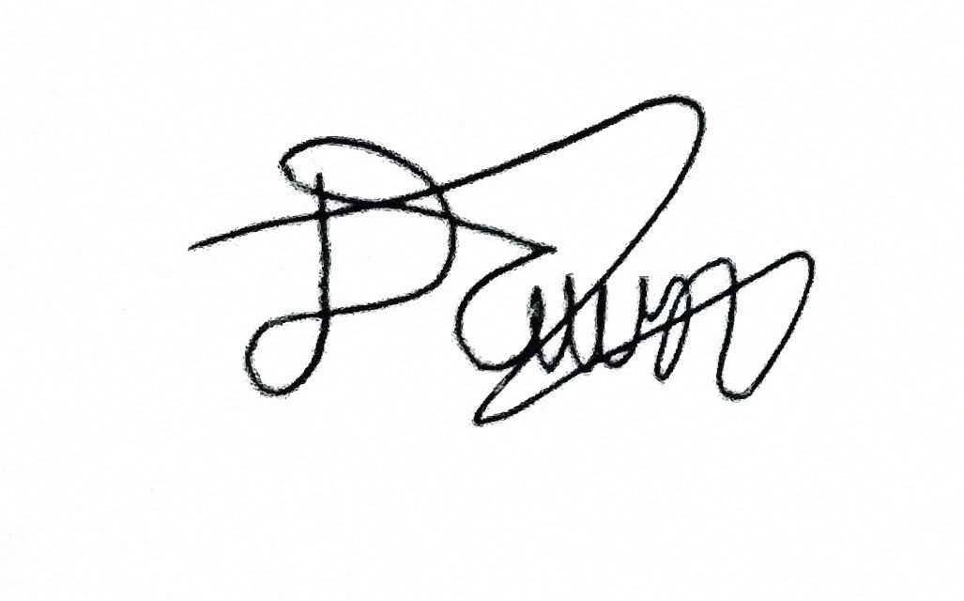
Rogelio Porras | 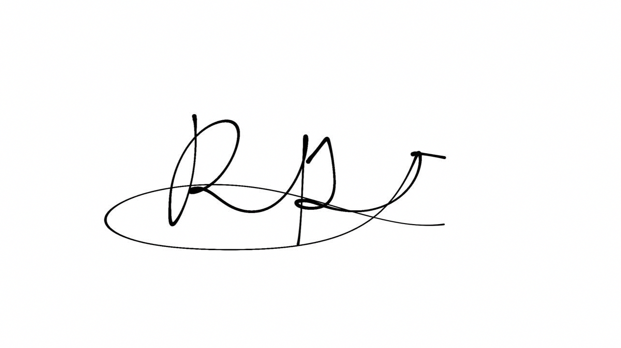
John Ashley Alba | 
Ralph Blanco | 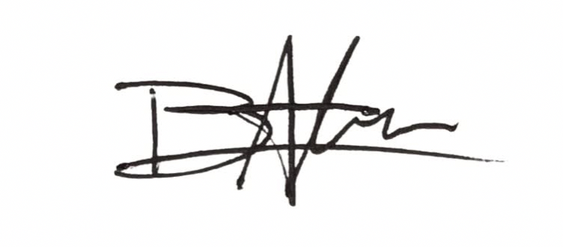

3. Team Contribution Matrix
The total contribution percentage must equal 100%.
Group Member | Assigned Task/Responsibility | Specific Contribution/Output | Contribution (%)
Dawn Andrei Pamesa | Project Manager; contacted BetterGov as the client; planning with Ralph. | BetterGov client contact; planning and method design with Ralph; the analysis and the proposal text, done with Claude and the custom GPT. | 30%
Rogelio Porras | Review of related literature and systems (RRL and RRS). | Sources and write-up for the RRL and RRS. | 23%
John Ashley Alba | Review of related literature and systems (RRL and RRS). | Sources and write-up for the RRL and RRS. | 23%
Ralph Blanco | Planning and brainstorming with the Project Manager. | Ideas and planning input for the proposal. | 24%
 |  | Total | 100%

